**PRACTICAL NO. 2**

**AIM :** To explore Libre office and comparing it with Microsoft office.

LIBREOFFICE : LibreOffice is a freely available, fully-featured office productivity suite. Its native file format is Open Document Format (ODF), an open standard format that is being adopted by governments world wide as a required file format for publishing and accepting documents.

LibreOffice Calc :

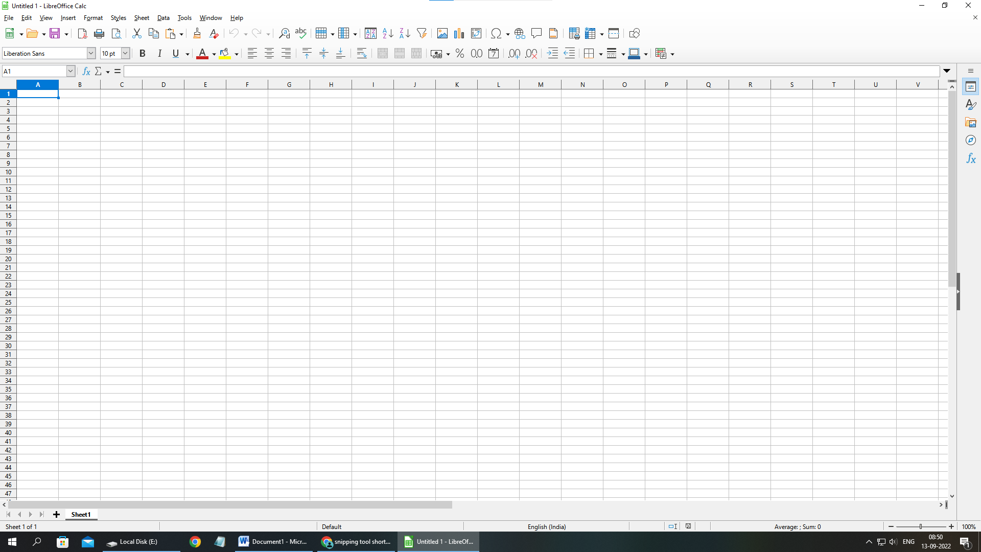

**LibreOffice Calc** is the spreadsheet component of the LibreOfficee software package

After forking from OpenOffice.org in 2010, LibreOffice Calc underwent a massive re-work of external reference handling to fix many defects in formula

calculations involving external references, and to boost data  performance, especially when referencing large data ranges.

Additionally, Calc now supports 1 million rows in a spreadsheet with macro references to each cell.

Calc is capable of opening and saving most spreadsheets in Microsoft Excel file format. Calc is also capable of saving spreadsheets as PDF files.

As with the entire LibreOffice suite, Calc is available for a variety of free and platforms, including Linux, macOS, Microsoft Windows, and FreeBSD.Available under the Mozilla Public License., Calc is  open-source software.

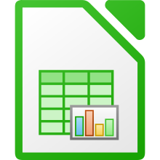

# 

# LibreOffice Writer :

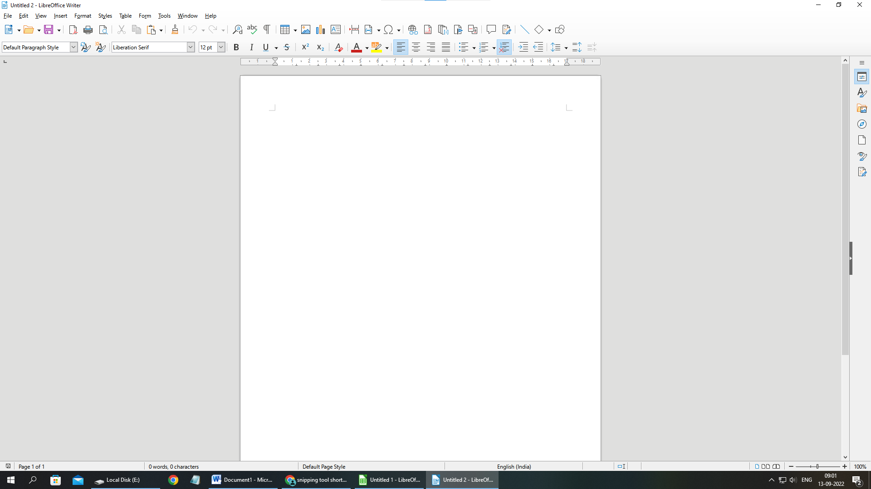

**LibreOffice Writer** is the free and open-source word processor and desktoppublishing component of the LibreOffice software package and is a fork of OpenOffice.org Writer Writer is a word processor similar to Microsoft Word and Corel's WordPerfect with many similar features, and file format compatibility.

LibreOffice Writer is released under the Mozilla Public License v2.0

As with the entire LibreOffice suite, Writer can be used across a variety of platforms, including Linux, FreeBSD, Mac OS X and Microsoft Windows